Office365 Email - IOS

Description
This documents describes the steps needed for a user to configure their IPhone or IPad to check UEL email and how to reconfigure their device to tale to Office365 after the migration.

Configuring Office365 for IOS

- Unlock the IPad/IPhone
- Select Mail

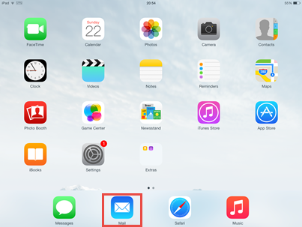

- Select Exchange
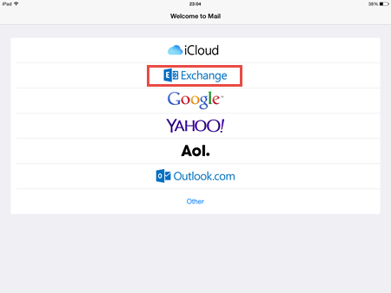

- Enter your username
- Enter your password
- Click Next

- Click Save

Reconfiguring IPhone/IPad after Migration

- Unlock IPad/IPhone
- Select Setting
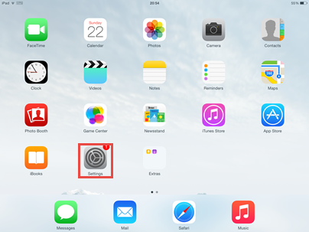

- Select Mail, Contact, Calendar

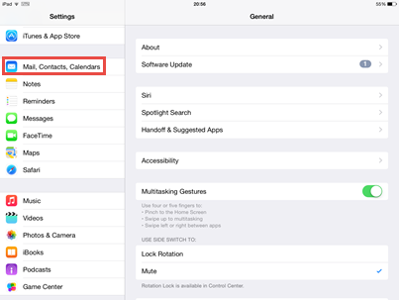

- Select Exchange account
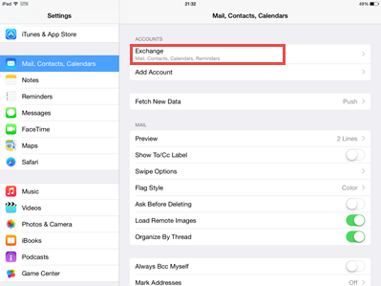

- Select Account

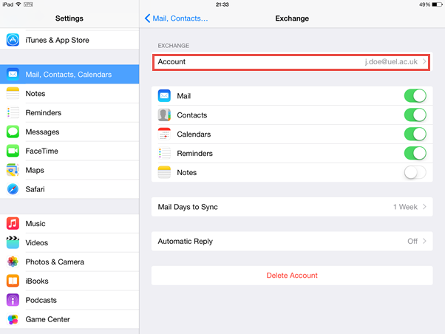

- Select server
- Please Note: The server may be dlwebmail.uel.ac.uk or st-webmail.uel.ac.uk

- Enter outlook.office365.com
- Select Done
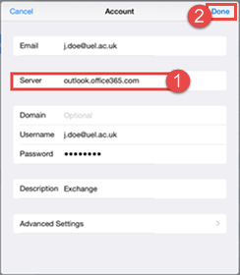

It will take a few minutes for the reconfiguring to take effect.

More Information
N/A

Properties
Affected Products: (Bold)
IPhones
IPad

Written by:
Ghaffar Khan

Date Written:
02/03/2015

