Office365 Email – Samsung Tablet

Description
This documents describes the steps needed for a user to configure their Samsung galaxy Tablet to check UEL email and how to reconfigure their device once their account has been migrated to Office365.

Samsung Galaxy Tablet – Configuring Office 365 Email

- Unlock tablet
- Select Email

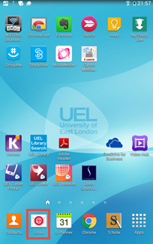

- Enter username i.e. j.doe@uel.ac.uk
- Enter Password
- Select Done

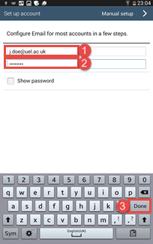

- Select Microsoft Exchange activeSync

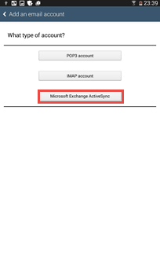

- Select Edit details

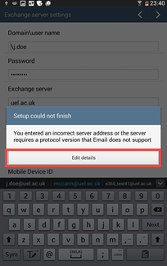

- Change user to username@uel.ac.uk i.e. j.doe@uel.ac.uk
- Change Server to outlook.office365.com
- Click >

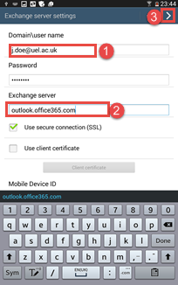

- Click Ok
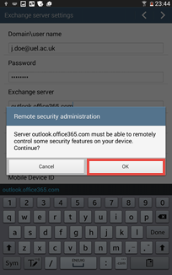

- Click >

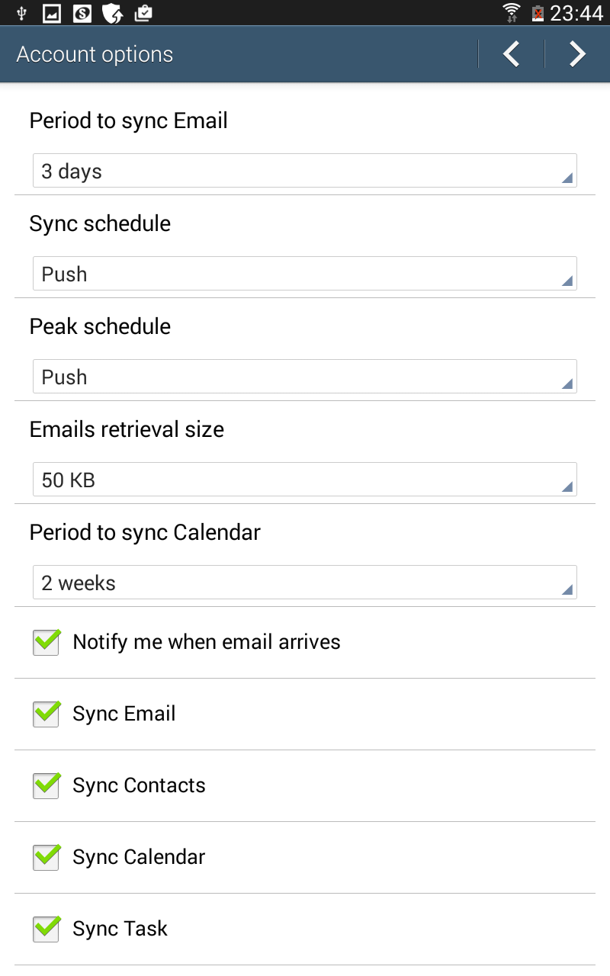

- Click Activate

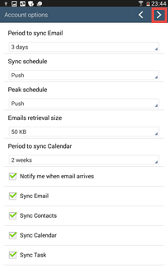

- Click Done

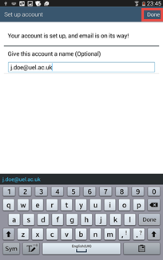

Samsung Galaxy Tablet – Delete Email Account

Samsung Galaxy – reconfigure Email

- Unlock tablet
- Select Apps Menu

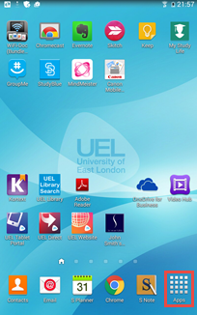

- Select Setting
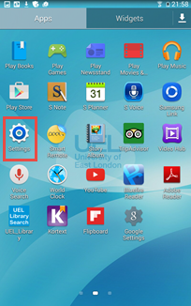

- Select Microsoft Exchange Activesync ( you may need to scroll down to find this)
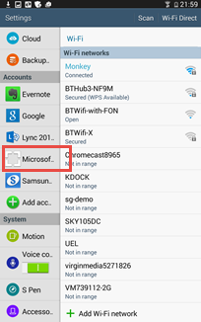

- Select Accounts
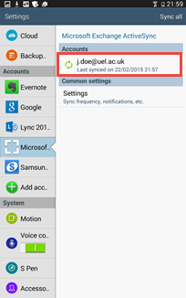

- Select remove account
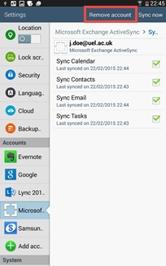

- Click Remove Account to confirm deletion
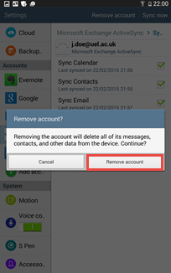

- Follow the step outline in Samsung Galaxy Tab – Configure Office365 Email

It will take a few minutes for the reconfiguring to take effect.

More Information
N/A

Properties
Affected Products: (Bold)
Samsung Galaxy Tablets

Written by:
Ghaffar Khan

Date Written:
02/03/2015

